THEORIC CONTENTS

* Lesson 2. Algorithms.
* Lesson 3. Data Types.
* Lesson 4. Operators and Expressions.
* Lesson 5. Input and Output

GITHUB CLASSROOM ASIGNMENT

**https://classroom.github.com/a/0JlrX3ll**

PROPOSED EXERCISES

Exercise 1. Modify the exercise 3 (practice 2 – face) for showing the result on screen and writing it to text file (ticked.txt)

Example:

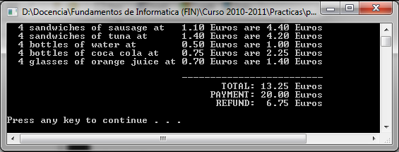

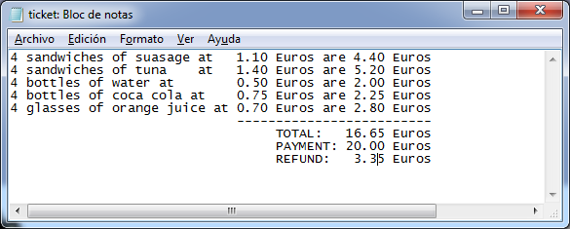

Exercise 2. Consider that the file "rainfall.txt" contains three lines. In each line, it contains the name of a city (without spaces), one blank space and three real numbers. Each one corresponds to the rainfalls (liters/m2) during the first three months of the year, respectively.

Design and implement a C program that creates a file (summary.txt), that contains the sum of the rainfalls during the first three months, for each city. The format of the new file should be tabular.

**Note**: Consider that the longest name of a city consists of 12 characters and the data in the new file must be aligned, with respect to the data in the same column. Such alignment should be obtained with **printf** modifiers.

Input file New File

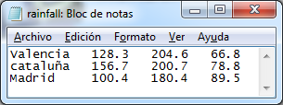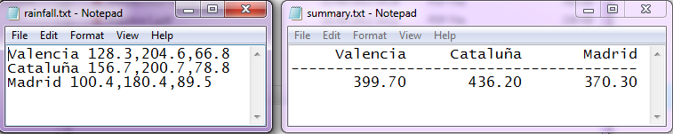

**Exercise** 3. Using the gets() and fprintf() functions, Design and implement a C program that accepts 3 lines of text from the keyboard and writes each line to a file named *text.dat*.

**Exercise** 4. Design and implement a C program that displays each line in the file *text.dat*. Consider this file is the same that your program has created in the previous exercise. Therefore, this file should contain 3 text lines.

**Exercise** 5. Design and implement a C program that duplicates one file. The names of the files (original and copy) must be given by the user. Therefore, this file should contain 3 text lines.

**Exercise** 6. Consider the file *employee.txt* contains the following information:

**Name S.S.N Hourly Rate Hours Worked**

B.Caldwell 163-98-4182 7.32 37

D.Memcheck 189-53-2147 8.32 40

R.Potter 145-32-9826 6.54 40

W.Rossen 163-09-4263 9.8 35

Each line in the file contains data of one employee (name, social security number, hourly rate (Euros) and the hours that he/she worked).

Design and implement a C program that reads the file *employee.txt* and computes and displays a payroll schedule. The output should list the Social Security number, name and gross pay for each individual. For each employee should display one different line and all the columns should be aligned.

**Exercise 7**. Design and implement a C program that creates one file with the following information:

**Car No. Miles driven Gallons used**

54 250 19

62 525 38

71 123 6

85 1,322 86

97 235 14

The file name must be ex7_alu.txt

**Exercise 8**. Design and implement a C program that writes, to the end of the file that has been created in the previous exercise, the total miles driven and the average of gallons that have been used.

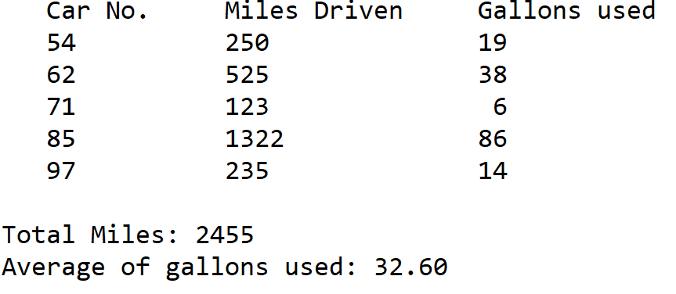

**Exercise 9.** Consider a file that contains two lines. In the first line appears the name of a person. In the second line appears his/her birth date.

*Example:*

Maria Gonzalez Herrero

03 08 1990

You have to consider the date format consists of two digits for the day, two digits for the month and four digits for the year.

Design and implement a C program that displays the age of the person whose name appears in the first line, considering that his/her birth date is those that appears in the second line. Take into account that 2020 is the current year.